**Affordance selection application:**

**Instructions:**

**What is an affordance?**

How would someone use a chair?

You can use it to sit. Or as clothes rack

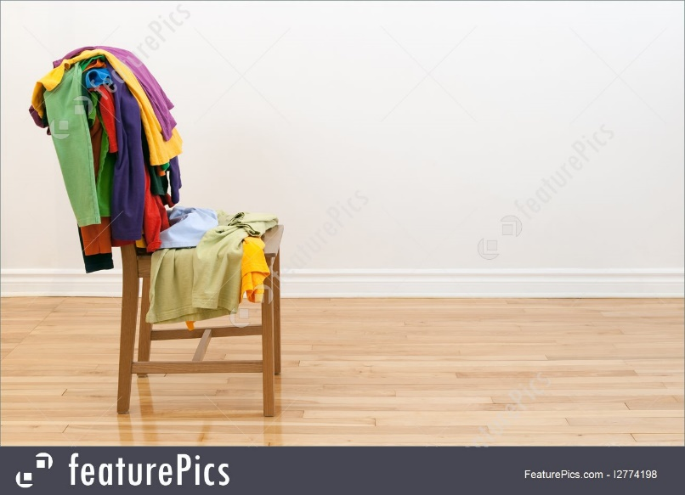

And in certain scenarios, you can use it:

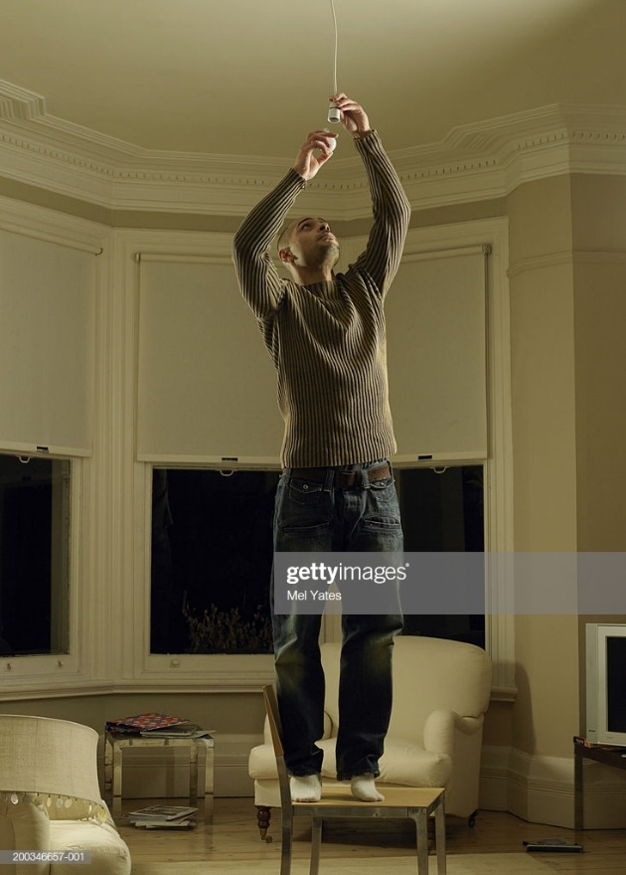To change a broken light bulb, or to escape some pesky critters

All these actions **afforded** by this chair that you instinctively pick up on are called **Affordances**.

Affordances can be context sensitive, for example if the light breaks, you can use this chair as a step ladder to reach the broken light and fix it. The chair afforded you the ability to reach said light.

Let us explore a few more examples:

First let’s consider a stick, for a human, it can be used as:

A walking cane for the blind or elderly or take better selfies for your Instagram fans



But for a hungry monkey, it would use it to pick up ants from their nest:



Now let’s look at a pen:

In your day to day life you would probably use it to write: 

But when assaulted mid-way through writing your award winning novel to-be by an armed robber it turns into a tool of self-defense: 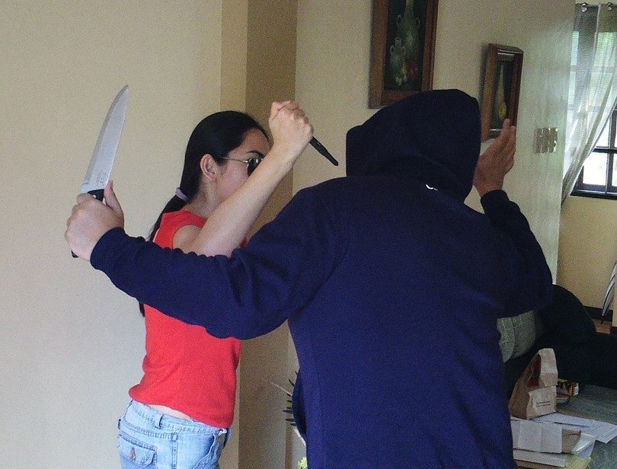

Another example where affordances are taken into the design of objects:

Here are two doors.

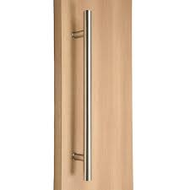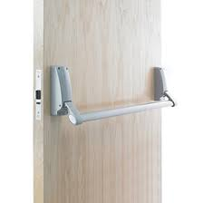

You can immediately recognize how to interact with both due to the shape of the handle without ever being told how to it.

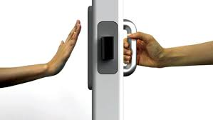

The handle design along with your life experiences and knowledge are what allowed you to figure it out.

This is the affordance of these doors. The left one affords you to **push** it while the right is meant to be **pulled**.

So, we can summarize by saying that affordances are how a certain **feature** of a product be of any use to **you specifically** in specific **context**.

This was a quick explanation of affordances. Below is a detailed explanation of the term.

**More about affordances:**

*“The term affordance refers to the perceived and actual properties of the thing, primarily those fundamental properties that determine just how the thing could possibly be used... Affordances provide strong cues to the operation of things.”*

-Don Norman.

An affordance, in the simplest terms, is what the object in question allows the user to do without any explicit instructions on how to do so.

When looking for affordances in the reviews, try to keep an eye for statements like “allows me to”, “lets me do”, “can be used to” and others along the lines of allowing the user to achieve a certain objective. Although these statements help in the identification of affordances, they are not a requirement as users can express affordances in a variety of ways.

Example:

*“So now the Sonos One and Alexa is working. I can ask it questions and add stuff to my shopping list. Yay. The range at which Alexa can hear you clearly is something like 15-20 ft around a corner and 25-30 ft if you're unobstructed. Any more than that and you'll run into issues.”*

From: <https://www.amazon.com/gp/customer-reviews/R8R0W93SEJAKP/ref=cm_cr_dp_d_rvw_ttl?ie=UTF8&ASIN=B074XLMYY5>

In the example above, we can see that the user uses the Alexa feature of the product to add items to his/her shopping list. This is not a built-in function of the product and not all owners of the product would use it in this manner. Thus, the Sonos One affords this user to add items to their shopping list.

Sometimes we get a general affordance that can be formalized into a specific term:

*“The sound profile of Sonos One and Play:1 are extremely similar. However, visually the products look different and nearly all of the internal components of Sonos One have been redesigned from the ground-up to create a smart speaker that can be natively controlled by your voice.”*

In this example, the user states that the product can be controlled by voice. In this case, we can formalize the affordance into a single term such as “controllability”.

Note that **not all** affordances can or should be formalized.

**Using the app:**

**Main page:**

Upon accessing the main page, you will be asked to input the username and password that were provided. After this step you should arrive at this page:

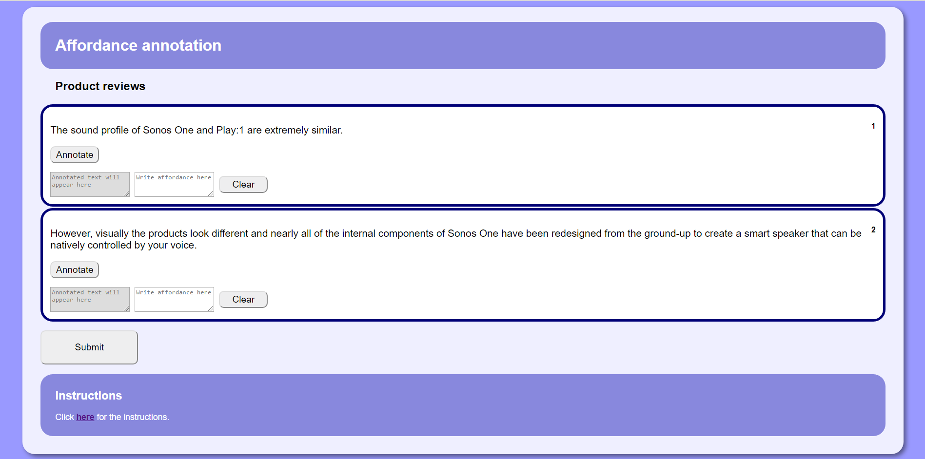

Each box represents a separate sentence that may or may not contain an affordance.

In case there are no affordances, you can leave the fields empty and move on to the next box/sentence.

**Affordance selection:**

If you managed to find an affordance in the sentence, you highlight the set of words that form the affordance using the mouse pointer. The image below shows this in action:

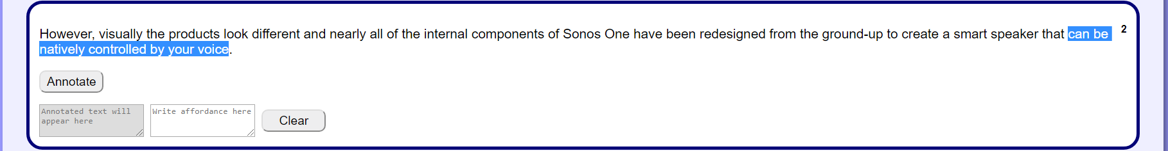

**Buttons and text boxes:**

After highlighting the desired affordance text, you must click on the “Annotate” button within that same sentence box to confirm the highlighted selection as an affordance. Upon doing this, the selected text will be highlighted in yellow and that same text will appear in the grey box bellow the button.

Example:

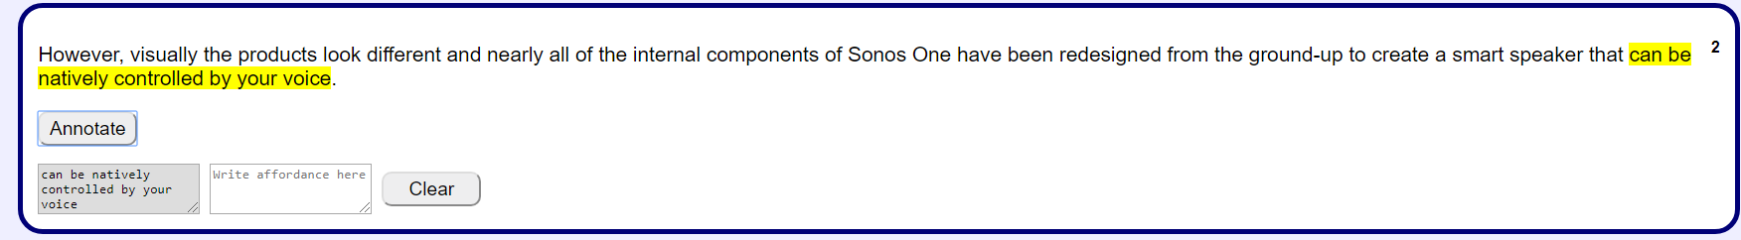

If the affordance can be formalized as a single word, you should write it in the white box next to the grey one that replicates the highlighted text. If not, the box is to be left empty.

Example:

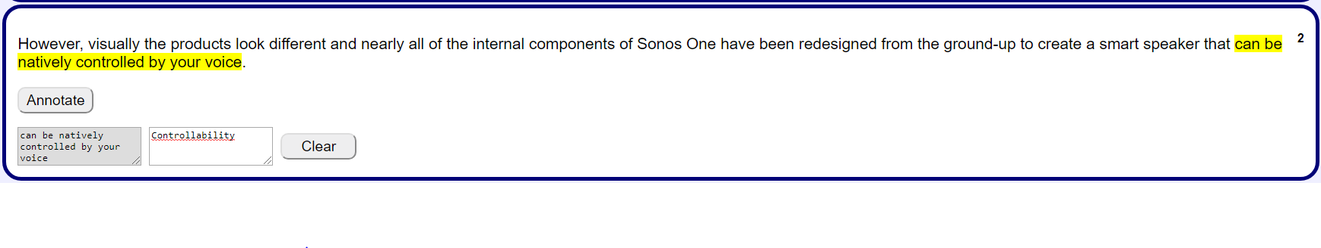

Note that both boxes can be expanded to see their full content by clicking the lower left corner and dragging to the desired size.

In case you made a wrong selection, you can reset the entire content of a specific sentence box by clicking the clear button. Note that clear will return the box to its original state and so all selections, highlights and written affordances will be removed from the specified box only.

Example:

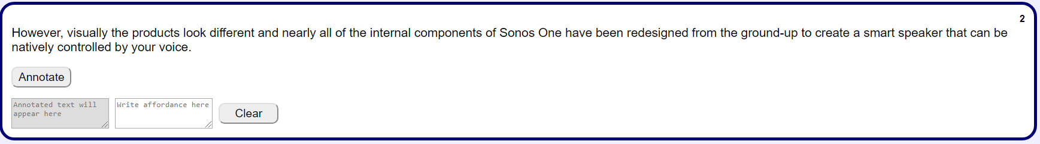

**Special case: Multiple affordances in a sentence:**

In some cases, there may be more than one affordance in a single sentence. If you happened to find one such example, you can redo highlighting process for that same sentence box while making sure that the two selections do not overlap.

Example:

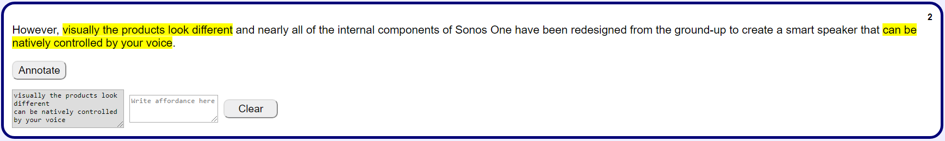

If you can formalize both affordances, you must write the first term, return to a new line by pressing enter and write the second term and so on.

Note the selection here is for demonstration purposes and is not a proper affordance.

Example:

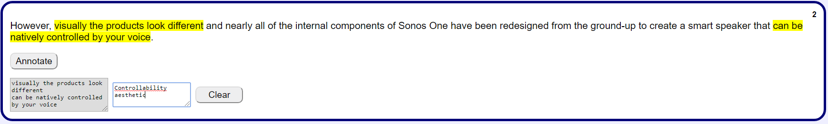

Notice how the second highlighted in the sentence element appears first in grey box. This is because it was the first to be selected and annotated in this example. And as such the written affordance “controllability” goes first in the box to maintain the order and association between the two.

As recap, do not overlap your selections when handling multiple affordances per sentence and make sure to maintain the order between the selection box and the affordance writing box.

**Missing affordances:**

Some users may express that a product or a feature did not fulfil what’s expected it of it, in that case we call this a missing affordance and should be highlighted the same as a normal affordance.

Example:

*“Controlling it by voice is great and all but I thought I could also do it by phone because I don’t want to repeat the same thing 20 time for Alexa to finally get it.*

**Submitting:**

When you are done with all the selections for the available boxes, click the “submit” button at the bottom of the page and you will submit your current set of sentences with their annotations and receive a new set of sentences to work with.

Example:

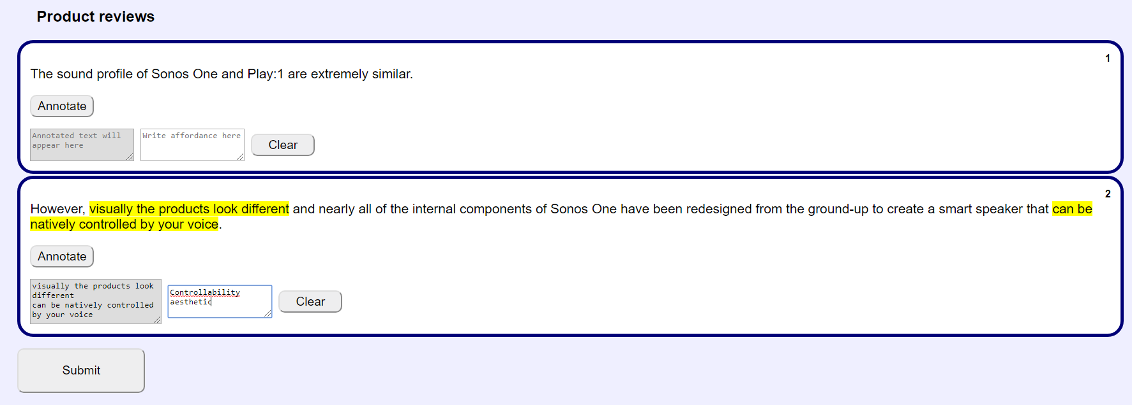

When no new sentences appear after submitting, that means you went through the entire list of available sentences and have completed your task. Congratulations.